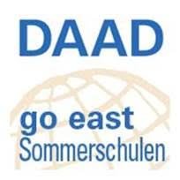
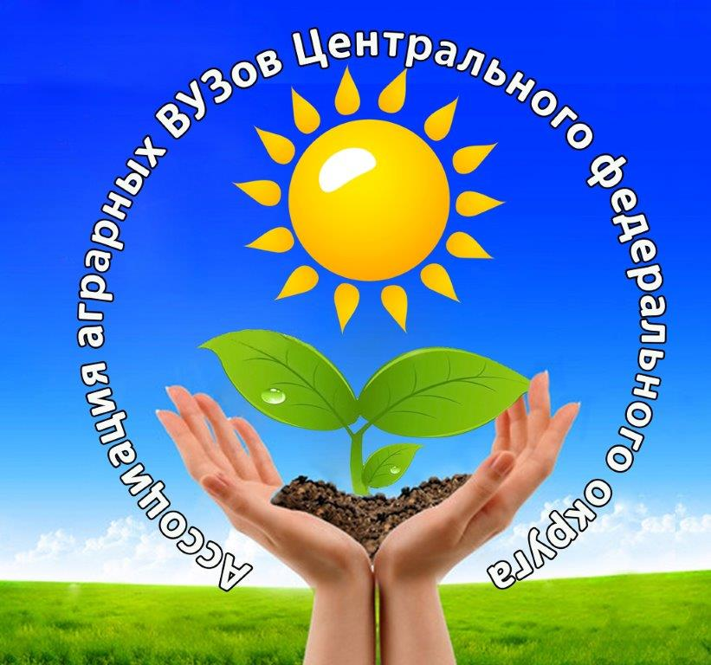
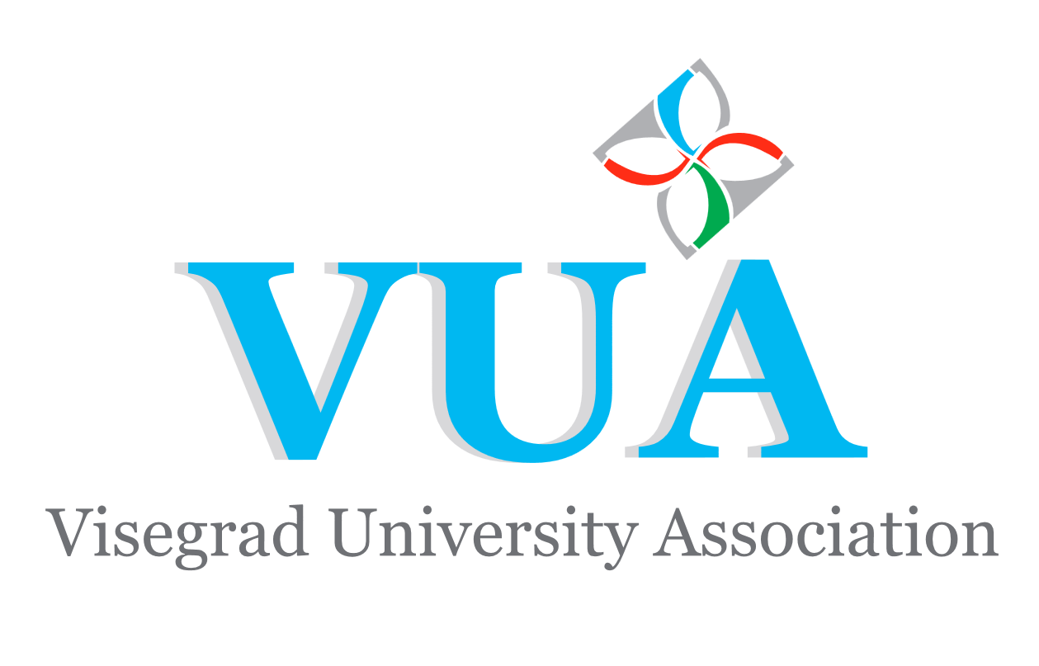
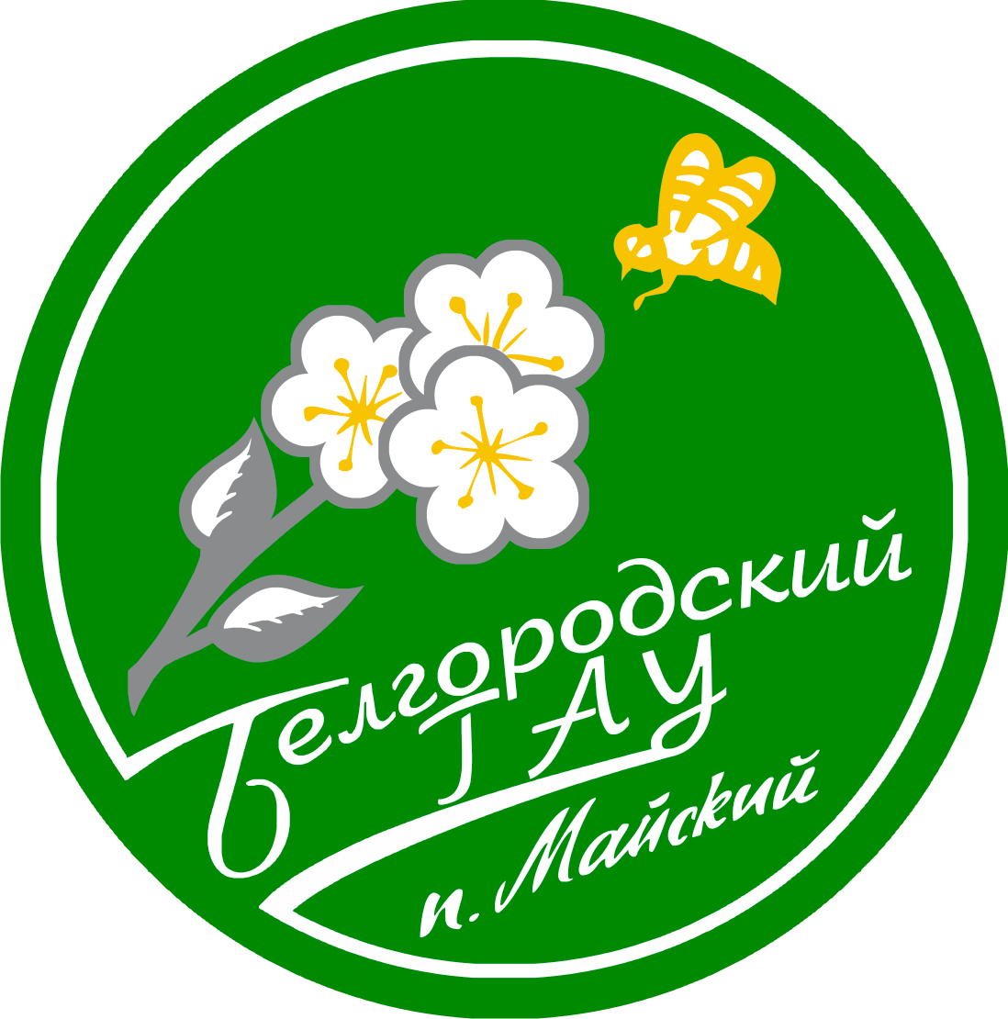
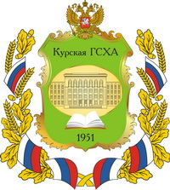

APPLY NOW for the International Summer School
AGRISUMMER IN BLACK SOIL REGIONS OF RUSSIA 2018

Kursk State Agricultural Academy and Belgorod State Agricultural University are glad to invite you to participate in the summer school "AGRISUMMER IN BLACK SOIL REGIONS OF RUSSIA" jointly organized by two educational institutions of higher professional training in Kursk and Belgorod regions. In 2018 the school will be held on July, 30 - August, 12. Students will have a wonderful opportunity not just to study different aspects of agricultural science, such as horticulture, dairy production, agricultural production processing etc., but also to visit agricultural enterprises in order to see with their own eyes how Russian agribusiness is organized as well as to compare the tendencies of agricultural production in different regions of Russia. The programme includes presentations and seminars, as well as practical classes and field experience. The working language of the school is English, German interpretation will be provided when necessary. The programme will last 14 days and the students will receive 4 credits for 44 academic hours of lectures/presentations combined with professional excursions to agricultural and food production enterprises.

Please, send the application documents mentioned below
to bsaa-inter@yandex.ru
before June 14, 2018:
1. Application form
2. Passport copy
3. CV
4. Cover letter (1 page) presenting the participant and motivation
5. Academic transcript of records
Participation Fee
Organization  (presentations, seminars, excursions, meals, transfer) | 350 €
Accommodation | 200 €
TOTAL Participation Fee | 550 €
You can also apply for one city (Belgorod or Kursk) paying half of the fee
If you would like to apply for any other scholarship program (which could help you to cover the participation costs) we would be happy to support you.

Use your chance to visit the leading agricultural enterprises of Belgorod and KurskBelgorod regions and to experience Russian culture and hospitality!
WEBPAGE: bsaa.edu.ru/agrisummer
FACEBOOK PAGE: agrisummerru

